**Emerging trends in the US banking system**

The US banking system is undergoing significant changes driven by technological advancements, shifting consumer preferences, and regulatory requirements.

**Gen AI and Cloud Computing:**

The rapid adoption of generative AI (gen AI) and cloud computing will transform banking operations, improving productivity and efficiency. AI will be used to enhance customer experiences, streamline processes, and optimize risk management.

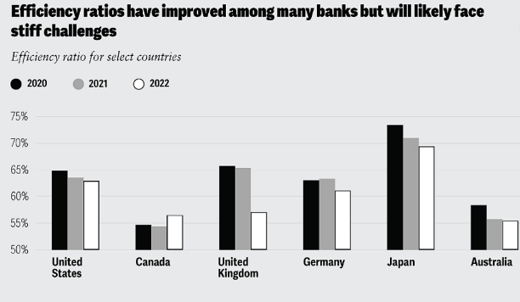

**Digital Banking and Fintech:**

Digital banking and fintech innovations will continue to grow in popularity, offering consumers more choices and convenience. Digital-only banks and fintechs will continue to attract deposits and offer competitive rates.

**Risk Management and Alternative Data:**

Banks will need to strengthen their risk management capabilities by leveraging alternative data sources, such as trading data and customer ratings, to refine customer segmentation models and improve credit approval processes.

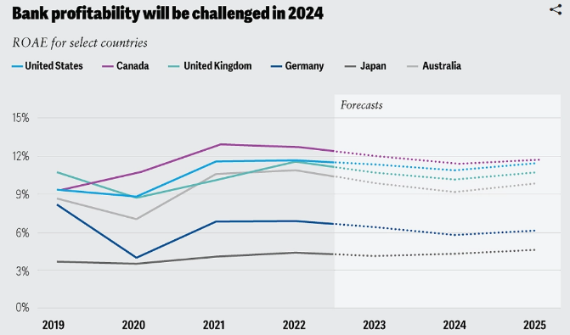

**Embedded Finance and Real-Time Payments:**

Embedded finance will become more prevalent, allowing businesses to access financial services seamlessly through their existing systems. Real-time payments will also become more widespread, enhancing the customer experience and improving operational efficiency.

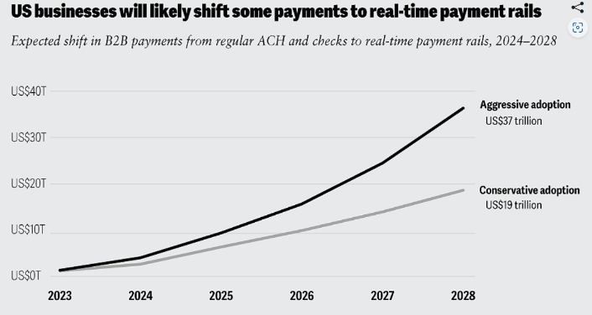

**Biometric Payments and Contactless Transactions:**

Biometric technology will continue to grow in digital payments, enabling secure and convenient transactions. Contactless payment options will also become more popular, transforming the payment landscape.

**AI-Powered Budgeting and Customer Experience:**

AI will be used to enhance customer experiences, improve budgeting tools, and increase productivity without adding costs. This will lead to more personalized services and better financial management for consumers.

**Consolidation and Mergers:**

The banking industry will likely experience consolidation and mergers, driven by regulatory pressures and the need for scale and stability. This will lead to more efficient operations and better risk management.

**Regulatory Focus on Capital and Liquidity:**

Regulatory requirements will focus on capital and liquidity, leading to increased scrutiny of banks' risk modeling and capital management practices. This will drive banks to optimize their operations and improve their financial resilience.

**How will generative AI specifically change the customer experience in banking**

Generative AI (Gen AI) will significantly change the customer experience in banking by enhancing personalization, efficiency, and security,

**Personalized Marketing:**

Gen AI can generate highly personalized marketing messages and offers based on individual customer preferences, increasing customer satisfaction and loyalty.

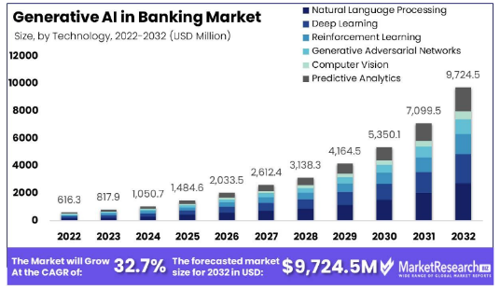

**Intelligent Chatbots:**

Gen AI-powered chatbots can engage customers more naturally and conversationally, providing seamless support and resolving queries efficiently.

**Predictive Analytics:**

Gen AI can analyze vast amounts of data to predict customer behavior, enabling banks to proactively offer tailored services and products, improving customer retention and satisfaction.

**Enhanced Customer Insights:**

Gen AI can generate insights from unstructured data, such as text and images, to provide a more comprehensive understanding of customer needs and preferences, leading to more effective customer engagement.

**Streamlined Operations:**

Gen AI can automate routine tasks and workflows, freeing up human resources to focus on high-value tasks, improving operational efficiency and reducing costs.

**Real-Time Fraud Detection:**

Gen AI can detect fraudulent activities in real-time, ensuring the security and integrity of customer transactions and accounts.

**Personalized Financial Advice:**

Gen AI can generate personalized financial advice based on customer interactions and preferences, providing a more tailored and effective financial planning experience.

Gen AI can analyze customer feedback and sentiment to improve customer service, ensuring that customer needs are met and issues are resolved efficiently.

**Ethical considerations for banks using Generative AI**

**The ethical considerations for banks using Generative AI with statistical data include:**

**Data Privacy:**

Ensure that the data used to train the AI model is anonymized and protected from unauthorized access to prevent data breaches and maintain customer trust.

**Bias Mitigation:**

Implement measures to mitigate biases in the data used to train the AI model, as these can lead to unfair outcomes and perpetuate existing social inequalities.

**Accountability:**

Establish clear guidelines and procedures for the use of AI-generated content, ensuring that the bank is accountable for the accuracy and reliability of the information provided.

**Transparency:**

Provide clear explanations of how the AI model works and the data it uses, ensuring transparency in the decision-making process and maintaining customer trust.

**Regulatory Compliance:**

Ensure that the use of AI-generated content complies with relevant regulations, such as the European Union's General Data Protection Regulation (GDPR) and the US's Gramm-Leach-Bliley Act (GLBA).

**Data Quality:**

Ensure that the data used to train the AI model is accurate, complete, and up-to-date to prevent errors and biases in the AI-generated content.

**Explainability:**

Implement measures to explain the AI-generated content and the decision-making process, ensuring that customers understand how the AI model arrived at its conclusions.

**Human Oversight:**

Ensure that human oversight and review are integrated into the AI-generated content process to prevent errors and ensure that the AI model is used responsibly.

**Continuous Monitoring:**

Continuously monitor the performance and biases of the AI model, updating and refining it as needed to ensure that it remains accurate and reliable.

**Ethical Governance:**

Establish clear ethical governance frameworks and guidelines for the use of AI-generated content, ensuring that the bank is committed to ethical practices and maintains customer trust.